**ARYAMAN MISHRA**

**Reg No:19BCE1027**

**Course Code: CSE2006**

**Course Name: Microprocessor and Interfacing**

**DIGITAL ASSIGNMENT 1**

**Q.1)** COUNT NUMBER OF VOWELS IN GIVEN LINE OF A TEXT/SENTENCE (5 Marks)

**Aim:**To count the number of vowels in given line of a text/sentence.

**Tools used:**DOSBOX 0.74 and Microsoft Macro Assembler (MASM) Version 6.11

**Algorithm:**

STEP 0:START.

STEP 1:Store the text/sentence in data segment.

STEP 2: Store the memory address of the data segment in the data segment (DS) register.

STEP 3: Store the memory address of the text/sentence in the Source Index (SI) register.

STEP 4:Clear register AX and BX.

STEP 5: Set BX register as vowel counter and store 0000H in BX register.

STEP 6: Loop till end of string.

STEP 7:Select a letter from the sentence using SI register.

STEP 8:Compare the letter with the vowels. If the letter is vowel increment BX register by 1 and increment SI by 1.

STEP 9:End Loop.

STEP 10:Halt.

STEP 11:STOP.

**Assembly Language Program:**

ASSUME CS:CODE,DS:DATA

DATA SEGMENT

STRING DB "My name is Aryaman Mishra$"

DATA ENDS

CODE SEGMENT

START:

MOV AX, DATA

MOV DS, AX

XOR AX,AX

XOR BX,BX

BACK: MOV AL, [SI]

CMP AL,'$'

JZ FINAL

CMP AL,'A'

JZ COUNT

CMP AL,'E'

JZ COUNT

CMP AL,'I'

JZ COUNT

CMP AL,'O'

JZ COUNT

CMP AL,'U'

JZ COUNT

CMP AL,'a'

JZ COUNT

CMP AL,'e'

JZ COUNT

CMP AL,'i'

JZ COUNT

CMP AL,'o'

JZ COUNT

CMP AL,'u'

JZ COUNT

INC SI

JMP BACK

COUNT: INC BL

INC SI

JMP BACK

FINAL: MOV AH, 4CH

INT 3

CODE ENDS

END START

**Result:**

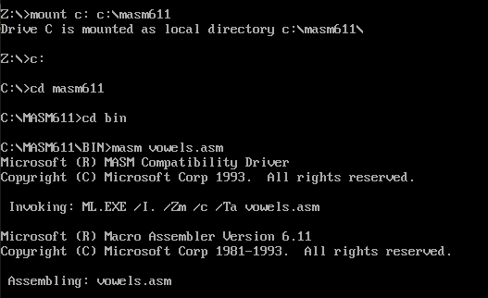

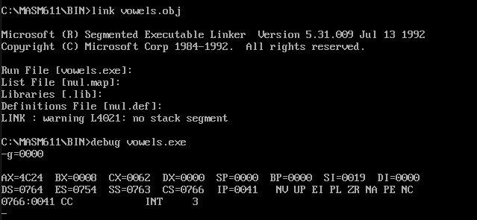

**Observation/Conclusion:** BX register contains 0008(8 in decimal representation).

Hence the number of vowels in the string ‘My name is Aryaman Mishra’ is 8.

Hence, the number of vowels in given line of a text/sentence were counted.

**Q.2)** Consider that an array contains the numbers 7,9,34, 45, 66. Write a program to pick only the odd numbers and find the sum and average. Save the result in the memory location 2000H. (5 Marks)

**Aim:** Find sum and average of odd numbers in given array and to save the result in the memory location 2000H.

**Tools used:** DOSBOX 0.74 and Microsoft Macro Assembler (MASM) Version 6.11

**Algorithm:**

STEP 0:START.

STEP 1:Store the array of numbers in the data segment of memory.

STEP 2: Store the memory address of the data segment in the data segment (DS) register.

STEP 3:Store the memory address of the Array in the Source Index (SI) register.

STEP 4: Store 2000H memory address in the Destination Index (DI) register.

STEP 5; Consider CX register as a counter and store 0005H in the CX register.

STEP 6: Set registers AX and DX to 0000H . Register DX will hold the sum of odd numbers.

STEP 7: Store 02H in register BL. Register BL will be used to find odd numbers.

STEP 8: Consider BH register as counter which will store the number of odd numbers present in the array. Store 00H in register BH.

STEP 9: Loop until CX is equal to zero.

STEP 10:Get a number from the Array using SI.

STEP 11:Check if the number is odd. If the number is odd, add it with DX.

STEP 12:Increment SI register by 1 and Decrement CL register by 1.

STEP 13:End Loop.

STEP 14: Store the sum of odd numbers at memory location 2000H (LSB) and 2001H (MSB).

STEP 15: Increment register DI by 2.

STEP 16: Find the average of the odd numbers by dividing the sum of odd numbers (stored in DX register then moved to AX register) by the number of odd numbers (Stored in BH register).

STEP 17: Store the quotient of the division ( i.e. the Average of odd numbers) at memory location 2002H and remainder of the division at memory location 2003H.

STEP 18: Halt.

STEP 19:STOP.

**Assembly Language Program:**

ASSUME CS:CODE, DS:DATA

DATA SEGMENT

ARRAY DB 7H,9H,34H,45H,56H

ODD DB ?

DATA ENDS

CODE SEGMENT

START:MOV AX,DATA

MOV DS,AX

LEA SI,ARRAY

MOV DI,2000H

MOV CX,0005H

XOR AX,AX

XOR DX,DX

MOV BL,02H

MOV BH,00H

LOOP1:MOV AL,[SI]

DIV BL

CMP AH,00H

JE NEXT

ADD DL,[SI]

INC BH

NEXT:INC SI

DEC CL

JNZ LOOP1

MOV [DI],DX

INC DI

INC DI

MOV AX,DX

DIV BH

MOV [DI],AX

INT 3

CODE ENDS

END START

**Result:**

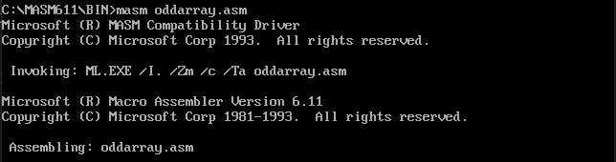

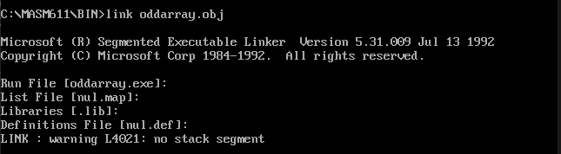

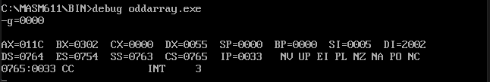

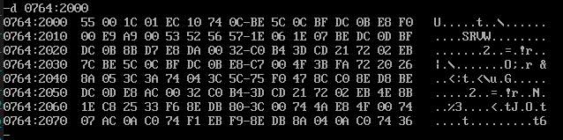

**Observation/Conclusion:**

Here, the sum of odd numbers is stored at 2000H (LSB) and 2001H (MSB).

**Sum = (0055)16**

The average is stored at 2002H and the remainder of the division is stored at 2003H

**Average = (1C)16**

Hence sum and average of odd numbers in the array was calculated and stored at memory location 2000H